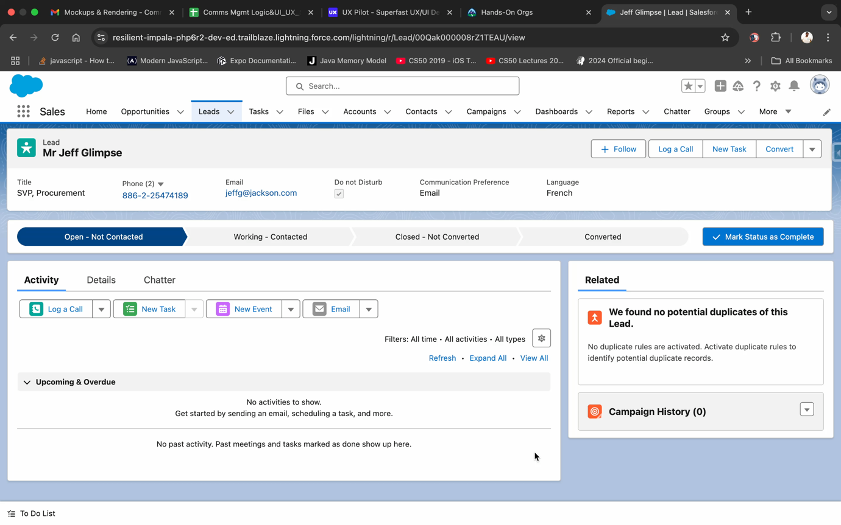
Property Details Autofill:
User Story: As a realtor, I want placeholders in templates to be visually highlighted and editable inline, so that, I can ensure the content is accurate before sending. I want a categorized template library that is visually distinct, so that, I can quickly find the right template.
- User should be able to use predefined email templates with filled in details to send emails to leads or contacts.
Templates can be categorized based on their purpose (like follow ups, new leads, promotions etc.).
User should be able to search for the template and pick required category of templates.

Above given is a screen recording showing the features required.

- User should see an error message if any of the fields in the draft email are missing.
